Homework 02

Due Wed Sept 19 before class

**Learning Objectives:**

* Review data representations, number manipulations, etc.
* To write/compile/link/run assembly code, based on this week’s demo

Math ScratchPad

Do these questions on paper, by hand, and submit to me before class next Wednesday. Please show all work. For Q1-Q3, try to do them without a calculator. (No calculator will be allowed for quiz ☺).

1. What is this number in binary?
   1. 57
   2. 204910
   3. A916
2. What is this number in hexadecimal? Evaluated if needed.
   1. 0110111102
   2. 402410
   3. 3016 + 10102
   4. 0xA5F + 0x0F1
3. Evaluate (89-45) in three different ways …
   1. Subtract in the given base, then convert to binary
   2. Convert 89 to binary, convert 45 to binary, then subtract
   3. Convert 89 to binary, convert -45 to binary (two’s complement), then add
   4. Which of the above methods is used by a computer? Why?
4. What are the hex and decimal representations of ASCII character G?
5. What are the hex and decimal representations of UNICODE character 大？ (This Chinese character is pronounced “da” meaning “big”).

Coding Workbench

Create a folder (yourname_homework02) and do the exercises below. Zip and submit this folder in D2L.

Every single file (.asm or any makefiles) should have header and comments that include YOUR NAME, DATE, and other details as per good coding practice.

1. Consider the “peach” void function example we did in class. This is a an assembly function that is called by a C driver.
   * Rename peach.asm to become fruits.asm.
   * Modify this file to include another function (or two!) inside (use other fruit names) that can be called by the C driver.
   * Each new function should output a different string related to that “fruit”
   * Update the C driver to call the different fruits.
2. Write an assembly language program (name.asm) to display a banner, with your name ☺ (similar to the one below; the border style does not need to be exactly the same; you can be creative)­­­­. Here are the constraints:
   * You must use no more than 5 string declarations.
   * Try to use as few lines of code as possible.
   * The banner should be “symmetrical”.
   * Comment your code nicely: header info, as well as in-line comments

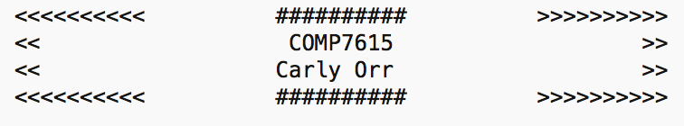

Submission D2L

Create a makefile to organize the above programming exercises.

Provide **all files & code** (and any readme files if needed) in zipped folder: yourname_homework02.zip

Marking:

|  |  |
| --- | --- |
|  | Max |
| Completeness | 4 |
| Files are well organized | 2 |
| Code is well commented and documented | 2 |
| Proper file naming conventions | 2 |